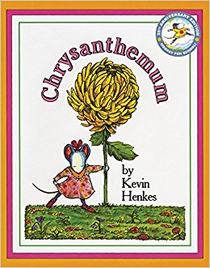
Hello K2 Families!

This week in K2 we are reading the book Chrysanthemum by Kevin Henkes. In the story, kids at school tease Chrysanthemum about her name until a new teacher comes to show her how special it is! We would love to share with students the meaning behind their names. Did you name your child after a family member or a special memory? Please write them a brief letter on the attached sheet for us to share with the class on Friday!
Thanks,
The K2 Team
Ms. Casado & Mr. Connor

Dear _________________________,

__________________________________

_____________________________________

_____________________________________

_____________________________________

_____________________________________

_____________________________________

_____________________________________

_____________________________________

_____________________________________

_____________________________________
Love,

