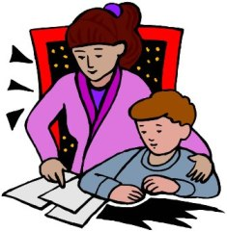
Homework!

Hello K2 Families,

This week we begin our All About Me unit in Room 105! Along with this exciting start is the start of K2 homework! This week students will be making an All About Me book in school as well as at home! The book children are creating for homework will be around questions you can help answer as their family. Children should be drawing detailed pictures and you can help them in writing down the words.

Moving forward, homework will be assigned on Mondays and due the following Monday. We suggest children complete one page a night and can finish any coloring or details over the weekend. Please feel free to message me on Class Dojo if you have any questions or concerns about getting homework in on time.

Thanks,
Mr Connor
mconnor3@bostonpublicschools.org

